**Chapter 1**

**THE PROBLEM AND ITS SETTING**

**Introduction**

In the vast fields of every industry, document printing has been in demand as it is a necessity for students and professionals alike as well as for the public. With document printing becoming a global trend, it comes with the demand for printing shops rising as not all people can afford printers or are at least not interested in getting one. While printing shops are spreading across the country, especially near schools and workplaces, it becomes a competition when it comes to prices.

A problem that a lot of people have been experiencing, not only in the printing industry but in every consumer-related situation, is the inconsistent pricing structures. In a business, pricing is crucial as it affects how consumers interact with their product or their service. Pricing inconsistency can have such factors as regional pricing, dynamic pricing, and personalized pricing (FasterCapital, 2024). Consumers may decide to find another service that offers more consistent and fairer pricing if other competitors are available in the area. However, the situation is not always like that.

Recent criticisms towards a local printing shop in Puerto Princesa, Palawan have caught the attention of Palawan News. Netizens have raised concerns about the unfair pricing of the said printing shop in which it does not have standard pricing in black and white and colored prints (Badilla, 2024). Although the printing shop owner defended the claim of having unfair pricing, she clarified that their rates have always been the same.

According to Article 81 of the Republic Act No. 7394 or the Consumer Act of the Philippines (DTI, 2022), the pricing of goods and services, such as document printing services, must be regulated to protect consumers from unfair prices. Also, the prices of each service must be disclosed to consumers for transparency. Although the printing shops post the prices of their printing services, it is not clear what the print covers, especially on colored prints. Sometimes, the price on colored prints changes according to its size and its price changes depending on the estimation of the service provider.

To support this information, the researchers made an online survey through Google Forms, with questions that are focused on the inconsistent pricing of print shops near PUP-CEA. Some questions are “Have you been affected by the high and random prices of printing services?”, “Have you ever been dissatisfied with the transparency of pricing in the printing shops?”, and “Have you ever been charged a higher price for colored printing even when the documents had only a small colored logo or image?” with “Yes” or “No” answers as the respondents’ choices. Most of their answers resulted in “Yes” which means they feel the inconsistency of the pricing of the printing shops when it comes to colored printing.

Aside from document printing pricing being inconsistent, there is a need for people to have access to more convenient and efficient ways of printing solutions. One solution that is expected to have a significant impact on the world of printing is to have a self-service printing kiosk (Data Analytics Visionaries, 2024)

Introducing InstaPrint: A Printing Kiosk with Standardized Pricing and Efficient Services Operated Through Coin and GCash Payments. This printing solution helps address the need for a more convenient and efficient way of printing while having a user-friendly interface designed to make the device easier. InstaPrint aims to ensure to have a fair and standardized pricing and its affordability to students while having flexible payment options with coins and cashless payments through GCash. Within this study, a discussion is to be made to have a brief understanding of the technical, operational, and innovative benefits of InstaPrint – highlighting the potential to revolutionize the printing services within PUP-CEA.

**Theoretical Framework**

**Technological Integration**

InstaPrint integrates a variety of technologies, including Arduino UNO, Python, HTML, CSS, and Visual Basic, ensuring smooth operation and robust security measures for user data (Aguanta et al., 2024). The Arduino UNO microcontroller board controls essential components such as the coin slot, printer, and coin hopper, facilitating seamless functionality and user interaction (Taşdemir, 2023). Arduino's user-friendly interface and extensive community support make it an ideal platform for rapid prototyping, particularly beneficial for beginners entering embedded systems development.

**User Satisfaction and Acceptance**

**Technology Acceptance Model (TAM)** assesses user perceptions of ease of use, usefulness, and behavioral intentions (Barlaan et al., 2024). TAM provides insights into user satisfaction and interaction with self-service kiosks like InstaPrint.

**Payment Flexibility and Operations**

InstaPrint accepts both coins and GCash, leveraging the increasing popularity of digital payments in the Philippines (Espeleta, 2022). This dual-payment approach enhances convenience and security for users while reducing the operational risks and costs associated with handling physical cash (Enojas et al., 2023). By embracing digital transactions, InstaPrint aligns with modern payment preferences, ensuring a seamless user experience and operational efficiency.

**Document Transfer and Accessibility**

Users can upload documents via Flash drive or wirelessly through a dedicated application, enhancing accessibility and usability (Aguanta et al., 2024). This feature supports various document formats like PDFs and PowerPoints, simplifying the printing process.

**Fair Pricing and Market Integration**

InstaPrint aligns with digital printing standards by implementing fair and transparent pricing strategies based on document complexity and size (AdrTechIndia, 2024). This ensures equitable service delivery across educational, library, and commercial settings.

**Image Processing**

InstaPrint leverages advanced image segmentation algorithms for precise document processing, enhancing pricing accuracy and service efficiency (Hu et al., 2019).

**Conceptual Framework**

The concept of this research is to create a printing solution with standard pricing. Therefore, this framework focuses on the process of printing and price standardization. The researchers adopted the Input-Process-Output model, which provides a clear and organized flow of details regarding the printing process.

Figure 1. IPO Conceptual Framework of InstaPrint

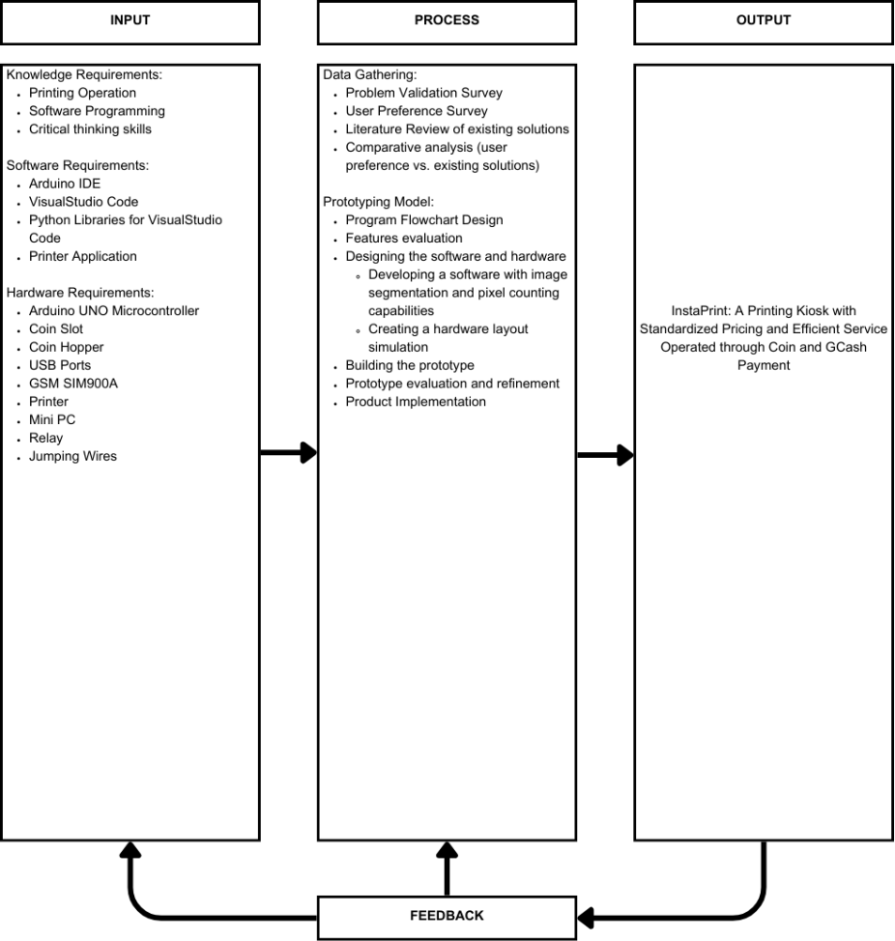

The INPUT includes knowledge of printing operations, software programming, and critical thinking skills. Other components are hardware such as an Arduino UNO microcontroller, a coin slot, a printer, and software such as the Arduino integrated development environment, Visual Studio code, and Python libraries.

The PROCESS of developing InstaPrint starts with data gathering through problem validation, a survey, and a literature review. It then moves on to the prototyping phase, including program flowchart design, feature evaluation, software and hardware development prototype construction, and evaluation before implementation.

The OUTPUT of the process would be the InstaPrint. A working printing kiosk offers standardized pricing, efficient service, and multiple payment methods for users. It is used to print documents in a variety of file types and accept payments with GCash and other currencies.

The FEEDBACK loop included in the project refers to the ongoing collection of feedback and data analysis to determine other areas that could be improved and developed in the InstaPrint kiosk. This mechanism guarantees continuous improvements to cater to user needs and improve overall user satisfaction.

**Statement of the Problem**

The objective of this study is to develop InstaPrint - an efficient and fair printing kiosk meant for solving the printing cost and accessibility issues near the College of Engineering and Architecture (CEA) at the Polytechnic University of the Philippines (PUP) in Sta. Mesa, Manila. Specifically, the researchers aim to address the following inquiries:

1. What are the main problems faced by students and faculty members of PUP CEA when using printing services?
   1. Service cost basis;
   2. File sharing method;
   3. Payment method.
2. What specific limitations or shortcomings exist in the current printing services offered near PUP CEA?
   1. Inconsistent and high service costs;
   2. Limited payment options;
3. How does InstaPrint address the identified research gaps in printing services?
   1. Standardized and fair pricing model;
   2. Multiple payment options (coins and GCash);
   3. Enhanced accessibility and user experience.
4. What are the developmental stages of InstaPrint?
   1. Feature identification;
   2. Product design;
   3. Prototyping;
   4. Implementation.
5. How does InstaPrint enhance the overall user satisfaction of PUP CEA students and faculty members?
   1. Ease of use;
   2. Accessibility of services;
   3. Quality of printed materials.
6. What impact does InstaPrint have on the time efficiency of printing services for PUP CEA users?
   1. Reduction in waiting time;
   2. Speed of transaction completion;
   3. Availability of kiosks.

**Hypothesis**

There is a significant difference in customer satisfaction between traditional printing services and self-service InstaPrint printing kiosks. Customers using InstaPrint kiosks report higher satisfaction levels due to greater convenience, speed of service, and potentially lower costs compared to traditional printing services. InstaPrint has features that offer a more convenient and efficient way of printing documents. It also has a feature where an algorithm is used to standardize the price for each document. These features of the InstaPrint printing kiosk will result in higher satisfaction than traditional printing services.

**Scope and Limitations of the Study**

InstaPrint, the proposed printing kiosk at the College of Engineering and Architecture (CEA) of the Polytechnic University of the Philippines (PUP) in Sta. Mesa, Manila, aims to provide a fair and standardized pricing model for document printing based on the color content in each file. This system will support document uploads in PDF, DOCX, PPTX, JPG and PNG. By utilizing image segmentation, the kiosk will determine the printing cost based on the color content on the files, providing utmost fairness in pricing for all users.

InstaPrint operates both on cash and online payment, accepting one-peso, five-peso, ten-peso, and twenty-peso coins as well as GCash balance using QR codes. One-peso coins will be used as change when using coin-based payment. The kiosk will only accept Philippine pesos to ensure compatibility with the local currency. Users will transfer files via flash drive or online upload via QR scan, ensuring a fast and seamless upload process. Document printing will support legal, short, and A4 paper sizes to accommodate diverse printing needs, from academic to personal use. The kiosk is planned to be placed on the 3rd floor of the CEA building, accessible to students, faculty, and other members of the PUP community. However, only one user can access the kiosk at a time to ensure privacy and reduce wait times.

To protect user data, InstaPrint will incorporate an auto-delete function that ensures files are automatically erased after the printing process, enhancing data security through self-destructing files. While InstaPrint offers a streamlined and fair pricing model, it does have some limitations. The system will only accept Philippine pesos for cash payments and does not support other currencies. Furthermore, InstaPrint cannot accept bills, limiting cash payments to coins only. Users who use physical currency to avail themselves of the service depend on the availability of change on InstaPrint’s stack of one-peso and coins.

**Significance of the Study**

This study makes some important contributions to the development of printing with standardized pricing and efficient services operated through coin and GCash payment.

**Students.** Most requirements of the students of PUP-CEA require them to print out these requirements. In line with this, the students face challenges with the subjective pricing of the files printed in printing shops which becomes unsystematic. InstaPrint solves this problem through standard pricing and offers a dual payment system catering to their preferences.

**Faculty.** This study benefits the faculty staff that also requires printing their materials for their daily needs. The availability and easy accessibility of the kiosk printer not only aids them to their needs but also makes it easier for them to access without the need to seek out traditional print shops.

**Future Researchers.** This research is open for other future researchers who aim to improve and broaden the scope and limitations of the study. This study can serve as their initial data which can be beneficial for the further development of their study which can focus on the improvement of InstaPrint's functions and services.

**Definition of Terms**

**Arduino Microcontroller.** A programmable device used to send signals to relays, activating the corresponding hopper based on the value of the detected coin. It ensures efficient and controlled dispensing of change to users.

**Coin Hopper.** A component used for coin processing and temporary storage of coins.

**Coin Slot.** An opening in a printing kiosk designed for the insertion of coins.

**Embedded System.** A specialized combination of computer hardware and software created to perform a specific function.

**Flash Drive.** A portable electronic device with flash memory used for storing and transferring data to or from devices such as computers and digital cameras.

**GCash.** A globally recognized micropayment service turning a smartphone into an electronic wallet or e-wallet for safe, quick, and easy money transfers.

**Image Segmentation.** A process of dividing a digital image into multiple segments or regions to simplify or change its representation for easier analysis.

**Microchip ATmega328P.** A low-power CMOS 8-bit microcontroller based on the AVR enhanced RISC architecture, commonly used in embedded systems.

**Microcontroller.** A compact integrated circuit designed to control a specific operation within an embedded system.

**Pixel.** The smallest unit of a digital image, often represented as a tiny dot or square.

**Pricing Inconsistency.** Variations in pricing for the same product or service due to factors such as material costs, service charges, or other variables.

**Printing Kiosk.** A machine that allows users to print various types of documents.

**QR Scan.** A method of reading a Quick Response (QR) code, a type of barcode, by using a digital device. QR codes store data as a grid of square-shaped pixels.

**Relay.** An electrically operated switch that transfers signals to other devices, enabling remote or automated control in various applications.

**Standardized.** Adhering to a set standard to ensure consistency and regularity in operations or outputs.

**Chapter 2**

**REVIEW OF LITERATURE AND STUDIES**

**Introduction**

Printing services are now essential to people's lives in an information-driven society. From the needs of students to working professionals or businesses, they help them accomplish tasks filled with information that could benefit society. There are lots of innovative printing solutions out there that have significantly changed users' expectations. One of these is printing kiosks, which have become a popular alternative to printing shops, which are in demand, especially in locations such as schools, libraries, and the workplace.

The idea of developing a printing kiosk on the campus may solve the problems of the students who need affordable, reliable, and quick printing solutions. It is convenient as there are many options for printing kiosks. It is also self-serving, allowing users to manage their printing independently and without assistance. Moreover, the proposed printing kiosk is designed to reduce wait times and offer flexible printing options.

To correlate the importance of the review of related literature in this study, it serves as a building block as other studies were used as a foundation for this study. It helped formulate research questions, guide methodologies, and provide solutions to innovate past studies. It provides an understanding of the scope of the study but also guides the formulation of ideas to create a more innovative study. By studying and understanding the insights from existing research, the researchers can identify the solutions that can be made in this study that may contribute to the advancement and knowledge in the field of innovative printing solutions. Thus, a comprehensive review of related literature may be the basis for successful studies.

The researchers gathered related literature and studies from journal articles and websites pertinent to this study's development. The literature review encompasses a broad range of topics, including the evolution and current trends of printing kiosks, standardized pricing models, payment systems, and efficiency in self-service kiosks. This literature review aims to identify and analyze existing studies on automated printing kiosks, focusing on their application in educational settings. This review aims to identify key trends, gaps, and potential areas for future research, particularly in pricing models and user accessibility.

**Printing Kiosks**

Several studies were reviewed that discuss the historical development and technological advancements of printing kiosks. These studies trace the progression from traditional manual printing services to modern automated kiosks, highlighting significant innovations such as touchscreen interfaces and wireless connectivity.

The printing kiosk market has seen significant advancements in recent years, transforming these devices into versatile and user-friendly tools for printing documents, photos, and other materials. These kiosks are commonly found in public spaces such as libraries, schools, and copy centers, providing users with quick and easy access to printing services on the go (AdrTechIndia, 2024).

One key innovation in printing kiosks is the integration of touchscreen technology. This feature allows users to navigate printing options and select settings without needing a traditional keyboard or mouse, making printing more intuitive and user-friendly. This advancement has expanded the appeal of printing kiosks to a broader range of users (Dionisio et al., 2024).

Another significant development in printing kiosks is the ability to print from mobile devices. Many modern printing kiosks can connect to smartphones and tablets, enabling users to print documents and photos directly from their mobile devices. This feature has further enhanced the convenience of printing on the go, eliminating the need to transfer files to a computer before printing.

In addition to these advancements, printing kiosks offer a more comprehensive range of printing options. These include color printing, double-sided printing, and the ability to print on different paper sizes and types. This increased flexibility has made printing kiosks more attractive for users with diverse printing needs.

The future of the printing kiosk market looks promising, driven by the increasing demand for convenient and efficient self-service printing solutions. Key players in the market include companies like GWI (Hunan et al.), Beijing OSK Technology, Shanghai Zhuxin Intelligent Technology, and Advanced Kiosks, known for their high-quality products and reliable customer service (HackMD, 2024).

**Standardized Pricing using Image Segmentation Techniques**

Image segmentation is a process that divides a digital image into multiple segments to simplify its analysis. This technique is crucial for various applications, including determining the amount of colored ink used in printing. Studies have shown that image segmentation can accurately calculate printing costs based on color usage. By analyzing each page to determine the proportion of colored pixels, the process provides precise data that directly influences the pricing per page.

According to Hu et al. (2019), the study was conducted about an improved image segmentation algorithm based on graph cut theory and the artificial bee colony algorithm for multi-threshold segmentation. The proposed method introduces a new weight function that considers both the gray level and pixel location to determine the probability of pixel region membership. A novel cost function, applicable to both square and non-square images, is developed, and the optimal image threshold is identified by minimizing this cost function using the artificial bee colony algorithm. Experimental results on public datasets and commonly used images demonstrate that the proposed algorithm achieves better performance in terms of Information Entropy (IE), Peak Signal to Noise Ratio (PSNR), Structural Similarity Index (SSIM), Root Mean Squared Error (RMSE), and processing time compared to other segmentation algorithms.

Figure 2. Tree-level segmentation results of different algorithms: (a) origin image, (b) segmented image using Hu et al.’s method, (c) segmented image using BA algorithms, (d) segmented image using MMSA algorithms, (e) segmented image using IBA algorithms, and (f) segmented image using OTSU algorithms.

The algorithm introduced in this paper can attain greater Information Entropy (IE), higher Peak Signal to Noise Ratio (PSNR), higher Structural Similarity Index (SSIM), lower Root Mean Squared Error (RMSE), and reduced processing time compared to other image segmentation algorithms.

In the study by Cho et al. (2023), they propose an approach to optimize image-text similarity maps using cost aggregation. It leverages relational information among class categories and visual semantics, demonstrating effective segmentation and high performance. Open-vocabulary semantic segmentation involves labeling each pixel in an image using a diverse set of text descriptions. This study proposes a novel cost-based method to adapt vision-language foundation models, specifically CLIP, for semantic segmentation. By aggregating the cosine similarity scores, or cost volume, between image and text embeddings, the method effectively fine-tunes CLIP's encoders to segment both seen and unseen classes, addressing the limitations of existing approaches. Additionally, the study investigates strategies for aggregating the cost volume, considering its multi-modal nature, and evaluates various techniques for fine-tuning CLIP efficiently.

Figure 3. Qualitative comparison between feature and cost aggregation. Cho et al.’s approach (d) successfully segments the previously unseen class, such as “birdcage,” whereas approach (c) fails.

The proposed CAT-Seg framework fine-tunes CLIP’s encoders to adapt them for segmentation tasks. The method not only surpasses previous state-of-the-art performance in standard benchmarks, but also excels in scenarios with considerable domain differences. The demonstrated success across diverse domains underscores the potential of this cost aggregation framework to significantly advance open-vocabulary semantic segmentation.

**Pricing**

The study references Article 81 of the Consumer Act of the Philippines, which mandates fair pricing and transparency in service provision. Compliance with such regulations is crucial for printing shops to avoid legal repercussions and maintain consumer trust. InstaPrint's standardized pricing model aligns with these regulatory requirements, a significant advantage in a market where consumers increasingly value fairness and transparency.

The article "Print Shop Owner Clarifies Pricing Discrepancy Amid Online Criticism" by Badilla (2024) provides a pertinent case study in examining the importance of fairness and transparency in pricing. The article portrays a situation in Puerto Princesa where a local print shop encountered significant public criticism due to perceived inconsistencies in its pricing practices. Despite the owner's insistence on pricing consistency, the scrutiny from online sources pointed out discrepancies, highlighting the urgent necessity for transparent and standardized pricing protocols. This case underscores how opaque pricing structures can influence consumer perception and potentially damage the businesses' reputations.

In exploring pricing dynamics, FasterCapital (2024) delves into the complexities of inconsistent pricing structures across industries, elucidating regional pricing disparities, dynamic pricing algorithms, and personalized pricing strategies as influential factors contributing to consumer apprehension. The article contends that ambiguous pricing methodologies may engender perceptions of inequity among consumers, prompting them to seek alternatives characterized by more straightforward and more transparent pricing policies. This theoretical framework underscores the pivotal role of transparent pricing practices in cultivating consumer trust and nurturing long-term customer loyalty within competitive markets.

According to the Department of Trade and Industry (DTI), businesses are legally obligated to display price tags to prevent deceptive pricing practices and ensure transaction transparency. Non-compliance can result in penalties, emphasizing the regulatory framework's role in maintaining consumer protection and business integrity.

These articles collectively provide a comprehensive understanding of the issues surrounding pricing practices in the document printing industry. The Palawan News case study highlights the real-world implications of inconsistent pricing on consumer perception and business reputation. Meanwhile, FasterCapital's theoretical insights illuminate consumer dissatisfaction with opaque pricing structures. Lastly, the DTI's regulatory perspective underscores the importance of compliance with pricing transparency laws to build trust and avoid legal repercussions. InstaPrint's aim to introduce standardized pricing addresses these concerns by offering precise and consistent pricing for document printing services. InstaPrint aims to mitigate the risks associated with opaque pricing practices observed in traditional printing shops by adhering to regulatory requirements and consumer expectations for transparency. This approach enhances consumer trust and positions InstaPrint competitively by differentiating itself through ethical and transparent pricing policies.

**Payment Systems for Kiosks**

A comprehensive review of payment systems for kiosks was conducted, focusing on both traditional and digital payment methods. Articles and case studies examined the mechanics of coin-operated systems and the integration of mobile payments like GCash, providing comparative analyses to understand user preferences and the pros and cons of different payment methods.

Parameswari et al. (2019) discussed the development of an automated machine designed for public browsing and printing services. This system, centered on the utilization of Raspberry Pi, allows users to access printing services without human assistance through a pay-and-use model. Key components include a user interface for document selection and payment, automated printing mechanisms, and the use of an IoT virtual private cloud.

Diaz et al. (2022) investigated the socio-economic profiles, platform preferences, and factors influencing customer satisfaction among mobile money service users in General Santos City, Philippines. The research revealed a diverse user base with varied demographics, predominantly female. GCash was the dominant platform with a 96% user adoption rate, followed by PayMaya (70%) and CoinsPh (52%). Factors influencing customer satisfaction included "System Availability" positively impacted satisfaction, while "Reliability" had a slight negative effect. Other significant factors were convenience, security, trust, and accuracy. These findings suggest that service providers should prioritize system reliability and customer trust to enhance satisfaction. Policymakers and service providers can use these insights to improve offerings and meet the diverse needs of users, contributing to the understanding of mobile money services in this dynamic sector.

Using GCash as a payment option leverages the growing trend of digital payments in the Philippines, which has seen increased adoption due to convenience and security (Espeleta, 2022). Standardized pricing helps maintain transparency and fairness, making the service more attractive. Additionally, using digital payments reduces the need for physical cash handling, lowering operational risks and costs (Enojas et al., 2023).

**Efficiency in Self-Service Kiosks**

Literature on the operational efficiency of self-service kiosks was also gathered. Studies discussed methods to minimize downtime, optimize supply chains, and enhance user experience through intuitive design and technological innovations such as AI and IoT.

Self-service kiosks have been shown to boost overall business efficiency by automating and streamlining internal processes. They can digitalize repetitive tasks like order processing and payment collection, saving staff effort and reducing workloads. This allows businesses to deliver services more quickly and conveniently for customers (Concepts, 2024).

Self-service kiosks can operate 24/7, providing greater accessibility and extending a business's areas of operation compared to traditional service counters. This enhanced customer convenience has been found to improve the overall customer service experience (Shannon, 2023).

Studies have highlighted the importance of intuitive, user-friendly kiosk designs in promoting customer adoption and satisfaction. Attributes like ease of use, clear instructions, and the ability to resolve issues are critical factors driving positive perceptions and continued usage of self-service kiosks.

However, research also notes that businesses must carefully evaluate the potential risks and required investments before adopting self-service kiosks, as there is no guarantee that they will be well-received by customers (Concepts, 2024). Significant upfront costs and the potential for user errors or technical issues can act as barriers to implementation.

The literature indicates that self-service kiosks can enhance business efficiency through automation and improve customer convenience. However, successful deployment requires thoughtful design, robust technological capabilities, and a thorough understanding of customer needs and preferences (MoldStud, 2024).

**Case Studies and Related Projects**

Several case studies of similar printing kiosk projects were analyzed to identify best practices and common challenges. These studies provided valuable insights into successful implementations and the factors that contribute to their effectiveness.

Baisa et al. (2023) addressed the need for accessible and efficient printing services in schools, offices, and public places by developing a coin-operated printer. The system integrates a microcontroller with a coin slot to validate payments and initiate printing. Key challenges identified include coin recognition issues, printer connectivity problems, microcontroller programming errors, mechanical failures, user interface issues, security concerns, maintenance challenges, transaction record errors, and physical security vulnerabilities. Addressing these challenges requires hardware adjustments, software debugging, and regular maintenance to ensure reliable operation.

Parameswari et al. (2019) introduced an automated browsing and printing system that operates 24/7 using Internet of Things (IoT) technology. The machine activates a user interface upon coin insertion and sends the number of prints to the user's mobile phone. This innovation aims to provide uninterrupted service in public places, educational institutions, and offices, enhancing convenience and accessibility for users.

Arcibal et al. (2019) developed a self-operated printing vending machine designed to provide affordable, high-quality printouts without the need for an operator. The machine utilizes a touchscreen LCD, Internet-connected printers, and actuated coin and bill acceptors. The system is programmed using Python on a Raspberry Pi, enabling a "pay, print, and go" operation. However, the current iteration does not provide monetary change, focusing primarily on producing printed documents from a user-friendly display.

Dionisio et al. (2024) developed a document printing kiosk to address the needs of engineering students at Aurora State College of Technology. The kiosk provides a self-service printing solution that alleviates the lengthy queues at the registrar's office and computer shops. The system includes essential components such as a printer, touch panel, coin slot, and power supply, integrated with software like Windows 10, VB10, and C++. The study's findings indicated that the kiosk effectively meets user needs and enhances the printing experience within the college community.

The reviewed studies highlight the potential of automated printing kiosks to improve accessibility, efficiency, and user convenience in various settings. By incorporating modern payment methods and leveraging IoT technology, these systems offer viable solutions to common challenges associated with traditional printing services.

**Chapter 3**

**METHODOLOGY**

This chapter presents the research design, description of the research instruments used, statistical treatment to be used, as well as the process flow chart and the design project flow.

**Research Design**

This study aims to have standardized pricing of document printing. While achieving this, the study also offers a more convenient and efficient way of printing that would reduce wait times.

In the main problem, which involves the inconsistent pricing of nearby printing shops in PUP-CEA, the researchers had created an online survey that would be answered by the students to verify the need of an alternative printing service inside the campus.

The target participants in this survey are the students inside PUP-CEA. In this survey, the questions asked were based on their experiences in availing the printing services near PUP-CEA and along with their preferences.

The researchers designed a prototype that includes the hardware and software components of the printing kiosk. With the hardware, the researchers used the application SketchUp to create the design of the printing kiosk. For the software, the researchers developed the user interface of the website along with the source code that would identify the file to be printed and calculate its price based on its pixel count.

After all, another survey will be conducted along with usability tests to gather feedback from users of the developed prototype. The collected feedback will help verify the convenience and efficiency that this study was expected to deliver and to determine user satisfaction.

The researchers created a formula that would calculate the standards for the pricing of the prints in grayscale and in color. The formula is as follows:

**GRAYSCALE**:

*Cap* = capital per page

*Cink* = cost of paper

*Cpaper* = cost of paper

*P* = price set per page

*Pr* = profit per page

*S* = sheets of paper per *Cpaper*

Capital per page:

$$Cap= \frac{\left|Cink+Cpaper\right|}{S}$$

Profit per page: $$Pr= P-Cap$$

**COLORED**:

*Cap* = capital per page

*Cink* = cost of paper

*Cpaper* = cost of paper

*P* = price set per page

*Pr* = profit per page

*Px* = price of pixel count

*S* = sheets of paper per *Cpaper*

Capital per page (colored):

$$Cap= \frac{\left|Cink+Cpaper\right|}{S}$$

Profit per page (colored): $$Pr=\left|P+Px\right|-Cap$$

**Flowchart of Research Design/Process Flowchart**

Figure 4. Research Design/Process Flowchart

Figure 4 shows the research design and development process of InstaPrint. Several methods were used to prove the validity and necessity of the study, including surveys and literature reviews.

Figure 5. Flowchart of InstaPrint’s planned printing process.

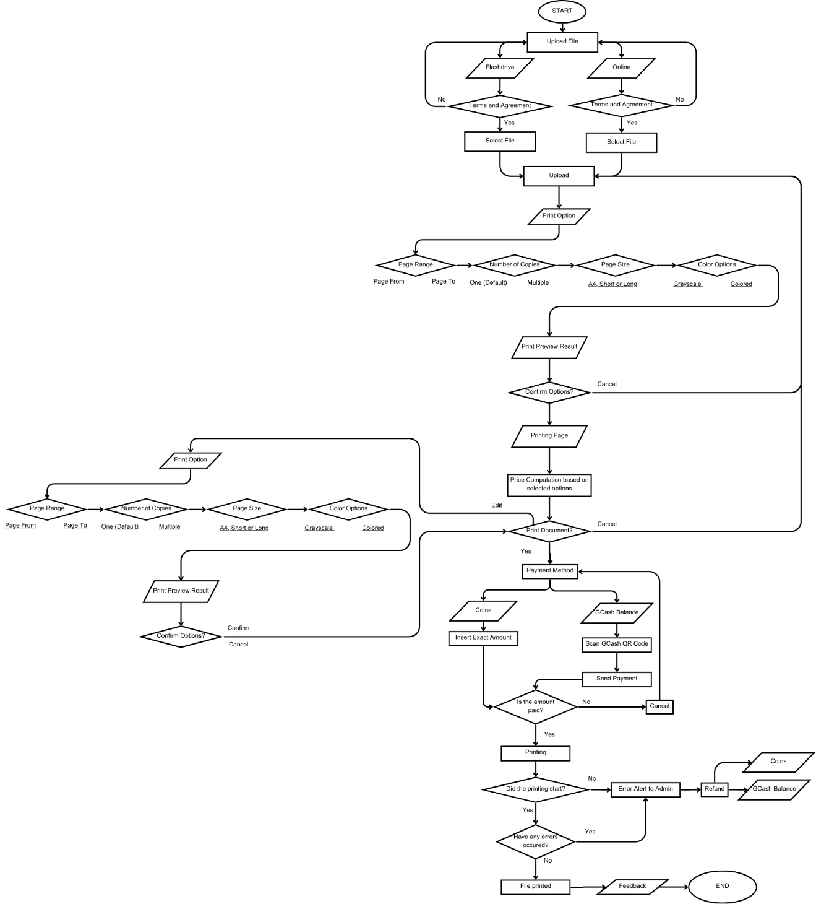

Figure 6. Flowchart for the Admin Website

Figures 5 and 6 show the processes within InstaPrint’s websites. Figure 5 illustrates the flow of action while using the kiosk’s UI website. Figure 6 represents the admin website where the administrators could keep track of the kiosk’s activity.

**Block Diagram**

Figure 7. Block Diagram of the InstaPrint Printing Kiosk

The block diagram shown in Figure 7 illustrates InstaPrint’s architecture. It showcases compatibility for GCash and Coin payment, as well as different file transfer methods through USB Flash Drive connection or online.

**Description of Research Instrument Used**

The researchers developed a research instrument by designing a comprehensive survey to collect evaluation and responses from potential users of the InstaPrint system, including the students of PUP-CEA. The survey was reviewed and validated by an expert to guarantee its reliability and validity. Feedback was provided by the expert regarding the clarity, relevance, and comprehensiveness of the survey items. The comments were considered when adjusting to improve the survey's effectiveness in collecting accurate and insightful data. The survey included questions that covered the areas of accessibility and convenience of the current existing printing services, the affordability and transparency of printing costs, the preference of users for payment methods, and their satisfaction with current printing services.

To test the performance of the InstaPrint system, the researchers adapted a validated questionnaire, ISO-25010. The questionnaire covered the quality characteristics of the InstaPrint system in terms of its functional suitability, performance efficiency, compatibility, interaction capability, reliability, security, maintainability, flexibility, and safety. The questionnaire was administered to a group of users who interacted with the InstaPrint system which includes the students who presented their feedback on the system's performance.

**Statistical Treatment**

The researchers used various statistical tools and methods to present, interpret, and analyze the data. Mean and standard deviation was employed to assess the significant differences between traditional printing methods and InstaPrint printing kiosk. The mean provided a central measure of performance or preference, while the standard deviation indicated consistency or variability in responses, offering insights into the InstaPrint kiosk's comparative effectiveness versus traditional methods. . For comparing the performance or preference between traditional printing methods and InstaPrint printing kiosk using mean and standard deviation, the following formulas are typically used:

where is the mean, $x_{i}$ are individual data points, and nnn is the number of data points.

where 𝜎 is the standard deviation, $x_{i}$ are individual data points, $\overline{x}$ is the mean, and $n$ is the number of data points.

Furthermore, the researchers employed a Likert scale to evaluate satisfaction, usability, and reliability. This scale enabled participants to express opinions and experiences on a spectrum, facilitating a detailed analysis of user perceptions.

Furthermore, the researchers employed a Likert scale to evaluate satisfaction, usability, and reliability. This scale enabled participants to express opinions and experiences on a spectrum, facilitating a detailed analysis of user perceptions.

Table 1

**Questionnaire used to measure satisfaction, usability, and reliability**

|  |  |  |  |  |  |
| --- | --- | --- | --- | --- | --- |
|  | 5  Strongly Agree | 4  Agree | 3  Neutral | 2  Disagree | 1  Strongly Disagree |
| **Usability** | | | | | |
| 1. Is the user interface of InstaPrint easy to navigate? |  |  |  |  |  |
| 1. Are the touchscreen controls of InstaPrint intuitive and easy to use? |  |  |  |  |  |
| 1. Is InstaPrint straightforward in uploading files and completing printing tasks? |  |  |  |  |  |
| 1. Are the instructions provided by InstaPrint clear and helpful? |  |  |  |  |  |
| 1. Are you satisfied with the overall accessibility of InstaPrint? |  |  |  |  |  |
|  | 5  Strongly Satisfied | 4  Satisfied | 3  Neutral | 2  Dissatisfied | 1  Strongly Dissatisfied |
| **Satisfaction** | | | | | |
| 1. How satisfied are you with the quality of prints produced by InstaPrint? |  |  |  |  |  |
| 1. Did InstaPrint meet your expectations with its printing accuracy? |  |  |  |  |  |
| 1. How satisfied are you with the availability of multiple payment options (coin and GCash) of InstaPrint? |  |  |  |  |  |
| 1. How satisfied are you with the overall pricing of InstaPrint services compared to traditional printing services? |  |  |  |  |  |
| 1. Overall, how satisfied are you with your experience using InstaPrint? |  |  |  |  |  |
|  | 5  Very Reliable | 4  Reliable | 3  Neutral | 2  Unreliable | 1  Very Unreliable |
| **Reliability** | | | | | |
| 1. How reliable is the wireless connectivity of the InstaPrint kiosk for uploading documents? |  |  |  |  |  |
| 1. How reliable is the technical service of InstaPrint when it encounters technical issues (e.g., paper jams, software glitches)? |  |  |  |  |  |
| 1. How reliable is the print output consistency of the InstaPrint kiosk across different printing jobs? |  |  |  |  |  |
| 1. How reliable is InstaPrint when it comes to its uptime and availability during your intended use? |  |  |  |  |  |
| 1. Is InstaPrint reliable when it comes to the security of your documents? |  |  |  |  |  |

Responses were aggregated and statistically analyzed using methods such as Analysis of Variance (ANOVA) to determine if there were statistically significant differences between the satisfaction levels, usability experiences, and perceptions of reliability regarding the kiosk compared to traditional methods.

The researchers utilized appropriately labeled statistical tables to ensure clarity in presenting their findings. These tables effectively summarized the data and facilitated a clear understanding of the results. Additionally, percentages were used to contextualize individual responses within the dataset, providing a comprehensive view of participant sentiments and preferences.

**Program Desired Output**

The researchers utilized Visual Studio Code along with HTML, Bootstrap, JavaScript, and Python for developing InstaPrint. Visual Studio, developed by Microsoft, is a robust integrated development environment (IDE) primarily used for software development. In contrast, Visual Studio Code is a lightweight and flexible code editor aimed at enhancing efficiency and simplicity in coding tasks. Both tools cater to developers in creating and modifying applications effectively.

1. **Admin Interface**

Figure 8 shows the admin interface for InstaPrint’s website wherein the admin is required to enter the username and password to access the dashboard of the system.

Figure 8. Admin interface of InstaPrint’s website

1. **End-Users Interface**
2. **Landing Form**

Figure 9 shows the landing form, where the user is required to choose how he/she wants to upload the document that is going to be printed.

Figure 9. Visual representation of the user’s file upload options

1. **Print**
   1. **Online**

Figure 10 displays the interface when the user selects "Online" to upload the file. It features a QR code for direct access to the website and provides the actual link for manual entry into the browser's address bar.

Figure 10. Visual representation of InstaPrint’s website after the uses chooses “Online”

* + 1. **File Selected**

Figure 11 shows the interface when the user uploads a file through the website. The file will appear on the system, and the user will be asked to choose which file to print. The system will then ask for confirmation before continuing the process.

Figure 11. Visual representation of InstaPrint’s website after the uses chooses a document

* + 1. **Page and Color Options**

Figure 12 shows the interface where the user needs to choose between “Grayscale” for black and white output, and “Colored” for colorful output. Also, the pages that the user wants to print

Figure 12. Visual representation of InstaPrint’s website for page and color options

* + 1. **Colored**

Figure 13 shows the interface after the user chooses “Colored.” The system will show the segmented images from the document for the transparency of the pricing.

Figure 13. Visual representation of the segmented images as well as the total amount after choosing “Colored”

* + 1. **Grayscale**

Figure 14 shows the interface after the user chooses “Grayscale.” The system will show the total pages detected from the document for the transparency of the pricing.

Figure 14. Visual representation of the total number of pages after choosing “Grayscale”

1. **USB Flash Drive**

When the user chooses the “Flash Drive” method of file upload, Figure 15 shows the interface. The user is required to browse for files and select one file to upload. After that, Figure 16 will show up, notifying the user, showing the name of the file that they selected, and asking for confirmation.

Figure 15. Visual representation of manual upload

Figure 16. Visual representation of showing the file is uploaded

1. **Payment Method**
   1. **GCash**

Figure 17 shows the payment interface. The user must choose between two payment methods: "GCash" or "Coins." When the user selects "GCash" as their method, the system shows an interface (Figure 18) where they scan a QR code corresponding to the GCash account where they will pay. After a successful payment, see Figure 19, the interface will show that the document is now printing and will also provide a notification after the successful printing.

Figure 17. Visual representation of the payment method options

Figure 18. Visual representation of GCash payment

Figure 19. Visual representation of the user’s document while printing

Figure 20. Visual representation of the user’s document while printing

* 1. **Coins**

Figure 21 shows the interface for coins as a payment method. The user is required to insert coins into the coin slot until the corresponding amount is met. The interface also provides a notification upon successful printing.

Figure 21: Visual representation of the detected amount of coins inserted into the coin slot

1. **Error Notification**
   1. **Paper Jam Error**

Figure 22 shows the error notification when a paper jam occurs in the printer. The system gives the user options to cancel or proceed the printing process.

Figure 22: Visual representation of paper jam error notification

* 1. **Low Ink Level Error**

Figure 23 shows the error notification when low ink levels are detected in the printer. The system gives the user options to cancel or proceed the printing process.

Figure 23: Visual representation of low ink levels error notification

**Prototype**

The researchers have created a prototype of InstaPrint. The application SketchUp was used in the design of the printing kiosk. SketchUp is a 3D modeling software that allows the creation of 3D models. This tool made it possible to create a prototype of InstaPrint to visualize the printing kiosk.

Figure 24. Front view of InstaPrint prototype

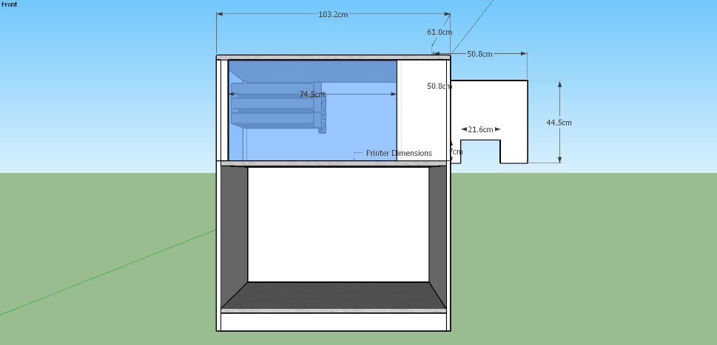

Figure 25. Top view of InstaPrint prototype

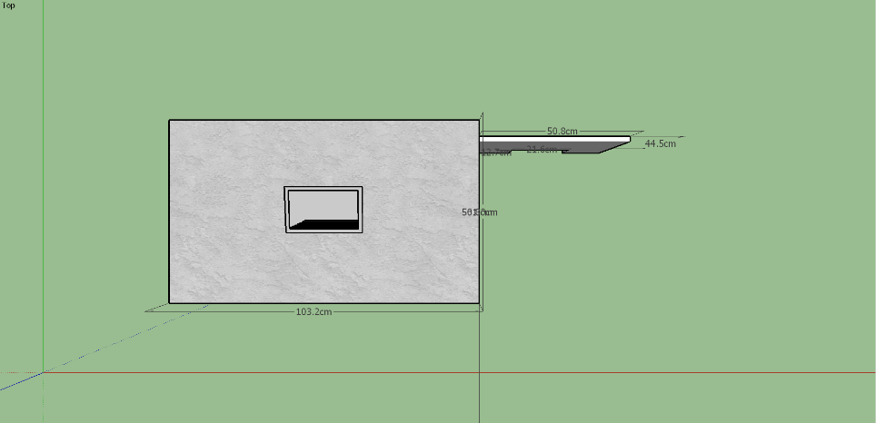

Figure 26. Left view of InstaPrint prototype

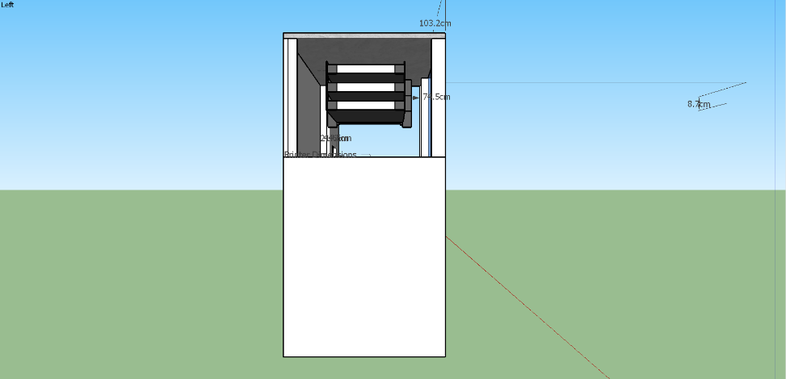

Figure 27. Right view of InstaPrint prototype

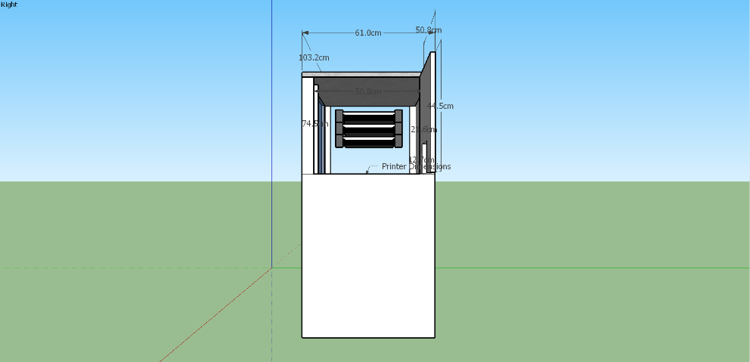

Figure 28. Isometric view of InstaPrint prototype

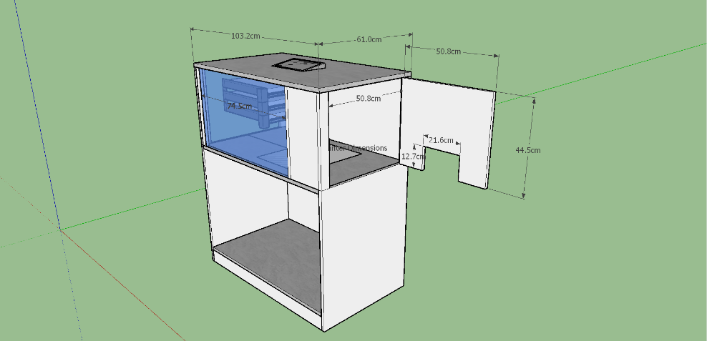

**Multiple Constraints**

Table 2

**Design Considerations and Constraints**

|  |  |  |  |
| --- | --- | --- | --- |
| Design Constraints Category | Considerations Percentage (%) | Design Criteria | Constraints |
| Technical | 60% | Hardware: Arduino UNO, Printer, Coin Slot, Coin Hopper | Availability and compatibility of hardware components |
|  |  | Software: Arduino IDE (C/C++), Python for backend, HTML/CSS for frontend | Software integration and performance issues |
|  |  | File Format Compatibility | Limit file sizes for efficient kiosk processing while supporting common document formats used by students and faculty (e.g., PDF, DOCX, PPTX). |
|  |  | Printing Process Optimization | Efficient print job management prioritizing urgency, with effective paper jam handling to minimize user intervention. |
|  |  | Integration with Payment Systems | Secure and reliable payment processing |
| Economic | 25% | Cost of implementation and operation | Ensure efficient use of resources to minimize operational costs. |
|  |  | Pricing Strategy | Balancing affordability and profitability |
| Social | 15% | User accessibility and convenience | Considering and incorporating feedback from the community to address their needs and preferences. |

**Technical Constraints for Design 1,2,3 (60%)**

Figure 29. Functionality Testing

The test assesses three different designs of the InstaPrint system. To examine the performance, compatibility, and reliability of the designs provided, each design undergoes multiple tests. First, **Hardware Compatibility** tests the compatibility of all the hardware components. Design 1 aims for 96% proper functionality, Design 2 targets 92% compatibility between Arduino UNO and printer, while intermittent issues with Coin Hopper objective for 90% compatibility for Design 3. Secondly, **Software Integration** tests the process of the combination of separate software programs into one element. Seamless integration aims for 98% for Design 1, while Hardware control bugs are 92% and performance lags are 95% for Design 2 and Design 3, respectively.

The third test, **File Format Compatibility** examines the compatibility of file formats provided by the users. Design 1 has 96% for efficient processing within limits, Design 2 has 92% for the size limit issues while the adjustment needed for PDFs is 95%. Fourth tests the **Printing Process Optimization** wherein the minimal user intervention of Design 1 is 97% while for Design 2 and Design 3, frequent user intervention is 90% and inconsistent prioritization is 93%, respectively. Lastly, the fifth test **Integration with Payment Systems**. Design 1 aims to predict secure and reliable integration to be 96% while unreliable integration of Design 2 to be 93% while reliability issue of Design 3 is 90%.

In general, the tests present a comprehensive evaluation of each design's functionalities, informing the users about its technical parameters which include compatibility, integration, optimization, and reliability.

Table 3

**Economic Constraints (15%) Design 1, 2,3**

**(Bills of Materials)**

|  |  |  |  |
| --- | --- | --- | --- |
|  | **Design 1** | **Design 2** | **Design 3** |
| Arduino Uno Microcontroller | 729 | 599 | 549 |
| Coin Slot | 399 | 399 | 395 |
| Coin Hopper | 1300 | 1250 | 1139 |
| GSM SIM900A | 228 | 549 | 349 |
| Printer | 1700 | 1700 | 1700 |
| Mini PC | 5150 | 5150 | 5150 |
| Relay | 50 | 50 | 50 |
| Total | 9556 | 9697 | 9332 |

Based on the evaluation of Design 1, Design 2, and Design 3 for the InstaPrint system, the results show that Design 1 is recommended. A summary of the evaluation is provided:

* **Technical score:** Design 1 scores higher in terms of hardware compatibility, software integration, file format compatibility, printing process optimization, and integration with payment systems.
* **Economic score:** Total material cost of 9,556 pesos.
* **Weighted Total Score:** Reaches a fair score by considering both economic (25%) and technological (60%) standards.

Design 1 provides exceptional technical performance guaranteeing the compatibility and capability of the InstaPrint system. While slightly higher than Design 3 in terms of material cost, its technical capabilities compared to Design 2 and Design 3 warrant its effectiveness and justify its benefits for optimizing the system. As a result, Design 1 is recommended for the improvement of the InstaPrint system.

**References**

Abdullah, S., Alpandi, R., Alwi, S., Salleh, M., & Ya’acob, F. (2021). Fintech As Financial Inclusion: Factors Affecting Behavioral Intention To Accept Mobile E-Wallet During Covid-19 Outbreak. Turkish Journal of Computer and Mathematics Education, 12(7).

AdrTechIndia. (2024). Interactive Kiosk | Information Kiosk. https://adrtechindia.com/product-category/audio-visual-solutions/interactive-kiosk/

Aguanta, J. R. F., Perez, T. A., Consulta, N. C., Macarista, H. B., & Quinzon, J. F. (May 2024). Development and Implementation of a Smart Coin-Operated Printing Machine.

Alwi, S., Salleh, M. N. M., Alpandi, R. M., Ya’acob, F. F., & Abdullah, S. M. M. (2021). Fintech as financial inclusion: Factors affecting behavioral intention to accept mobile E-wallet during Covid-19 outbreak. Türk Bilgisayar Ve Matematik Eğitimi Dergisi, 12(7), 2130–2141. https://doi.org/10.17762/turcomat.v12i7.3356

Arcibal, J., Azur, J.A., Puño, V., & Sabangan, R.R. (April 2019). Printing Vending Machine.

Baisa, J.L.M., Belga, J.R., Borja, W., & Dela Torre, J.C.B. (2023). Microcontroller Based Coin Operated Printer.

Badilla, E. (2024). Print shop owner clarifies pricing discrepancy amid online criticism. Retrieved from https://palawan-news.com/print-shop-owner-clarifies-pricing-discrepancy-amid-online-criticism/?fbclid=IwZXh0bgNhZW0CMTAAAR0cEl4PPZWUXg_y079MPx10BA08jHPH__FkGAlvc9A_GEET2nHo6yP3ibo_aem_4VKArfYSEMVSVctl7jhByg#google_vignette

Barlaan, R. C. S., Caleon, L. R., Maducdoc, K. C. R., & Soriano, J. A. M. (January 10, 2024). Currency-Operated Printing Kiosk.

Concepts, R. (2024a, May 16). The impact of Self-Service Kiosks on business efficiency. RSI Concepts - Top IT Solution Provider Company in Dubai, UAE. https://www.rsiconcepts.com/blog/2024/05/the-impact-of-self-service-kiosks-on-business-efficiency/

Data Analytics Visionaries (2024). Self-service Printing Kiosk Market Size | Emerging Growth for 2024-2031. Retrieved from https://www.linkedin.com/pulse/self-service-printing-kiosk-market-size-emerging-infff?fbclid=IwZXh0bgNhZW0CMTAAAR1qc-_MvMbDvtERZlpl3T5JVPbIZ1ErLiZRPvNWi8nErOO4hZiHthjpAjw_aem_Zibp4VBMPZNfQOacIt5wVQ

Dionisio, A.M.V., Ganancial, C.L.M., & Herminigildo, M.A. (February 16, 2024). Document Printing Kiosk Machine for Engineering Students.

DTI (2022). DTI warns business owners, establishments that price tag is a must. Retrieve from https://www.dti.gov.ph/archives/news-archives/dti-warns-business-owners-establishments-that-price-tag-is-a-must/?fbclid=IwZXh0bgNhZW0CMTAAAR002yx6snlKom_4E_5dYlrkK_VGBZnWMjqu4pz4LA81wf-KwWwcHwOzRtQ_aem_F-0pE5cEL2V6rWYCZrF7HQ

Enojas, M. J. B. et al., "Design and Development of a GCash Cash-in and Cash-out Machine," 2023 IEEE Symposium on Industrial Electronics & Applications (ISIEA), Kuala Lumpur, Malaysia, 2023, pp. 1-4, doi: 10.1109/ISIEA58478.2023.10212332. URL: https://ieeexplore.ieee.org/stamp/stamp.jsp?tp=&arnumber=10212332&isnumber=10212105

Espeleta, R. (2022). Utilization of Standard Electronic Payment System among Private Higher Education Institutions in the Province of Albay. JPAIR Multidisciplinary Research. https://doi.org/10.7719/jpair.v50i1.571.

FasterCapital (2024). Inconsistent pricing structures: Decoding the Enigma of Opaque Pricing. Retrieved from https://fastercapital.com/content/Inconsistent-pricing-structures--Decoding-the-Enigma-of-Opaque-Pricing.html?fbclid=IwZXh0bgNhZW0CMTAAAR0h59vLAW9MSwuwygGah0S9ZhypKUsO3Jd-tQIhmBB0IAVzeKGKQTTqLD4_aem_1Zkg4Q7LlWygzQDA9iy9DA

Ikli, S., Mancel, C., Mongeau, M., Olive, X., & Rachelson, E. (2021). The aircraft runway scheduling problem: A survey. Computers & Operations Research, 132, 105336. https://www.sciencedirect.com/topics/computer-science/first-come-first-served

Ikotun, A. M., Ezugwu, A. E., Abualigah, L., Abuhaija, B., & Heming, J. (n.d.). K-means clustering algorithms: A comprehensive review, variants analysis, and advances in the era of big data. Information Sciences, 622, 178–210. https://doi.org/10.1016/j.ins.2022.11.139

Image segmentation using Deep Learning: A survey. (Minaee et. al, 2024). Ar5iv. https://ar5iv.labs.arxiv.org/html/2001.05566

Lihua, Y. (2023). Research on image segmentation methods based on optimization theory. the International Journal of Advanced Manufacturing Technology/International Journal, Advanced Manufacturing Technology. https://doi.org/10.1007/s00170-023-12671-9

Marquez, V., Marquez, V., & Marquez, V. (2024, March 26). Screen Printing Pricing Strategies: A Practical guide - DecoNetwork. DecoNetwork. https://www.deconetwork.com/screen-printing-pricing-strategies-a-practical-guide deconetwork/?fbclid=IwZXh0bgNhZW0CMTAAAR2l8Fb6qwrnz35V8_RNSuT3tM22PCWm5yi5mNOTaWu6bw5b_7bCJp8E7bY_aem_ZmFrZWR1bW15MTZieXRlcw

Oston, P. (n.d.). Three ways to boost efficiency with self-service kiosks. Pan Oston. https://panoston.co.uk/articles/blogs/three-ways-to-boost-efficiency-with-self-service-kiosks

Parameswari, P., Thangavel, S., & Priyanka, E. (2019). Automated pay and use browsing and printing machine. International Journal of Innovative Technology and Exploring Engineering, 8(11S), 148–152. https://doi.org/10.35940/ijitee.k1032.09811s19

Printing Cost Estimator Tool: How to estimate and reduce the cost of printing your documents - FasterCapital. (n.d.). FasterCapital. https://fastercapital.com/content/Printing-Cost-Estimator-Tool--How-to-Estimate-and-Reduce-the-Cost-of-Printing-Your-Documents.html#Key-Factors-Affecting-Printing-Costs.html

Raja, P. S., & Rani, A. V. (2020). Brain tumor classification using a hybrid deep autoencoder with Bayesian fuzzy clustering-based segmentation approach. Biocybernetics and Biomedical Engineering, 40(1), 440–453. https://doi.org/10.1016/j.bbe.2020.01.006

Shannon. (2023, June 24). 10 Benefits of Self-Service Kiosks in 2023 | REDYREF. REDYREF Kiosks. https://redyref.com/10-benefits-self-service-kiosks/

Taşdemir, C. (2023, July 28). Arduino: The Ideal Gateway to Explore Embedded Systems (With some Limitations). Medium. https://medium.com/@CTasdemir/arduino-the-ideal-gateway-to-explore-embedded-systems-with-some-limitations-46092f65d416